**Experiment 15**

**Aim:**Design turing machine for the input a^nb^n

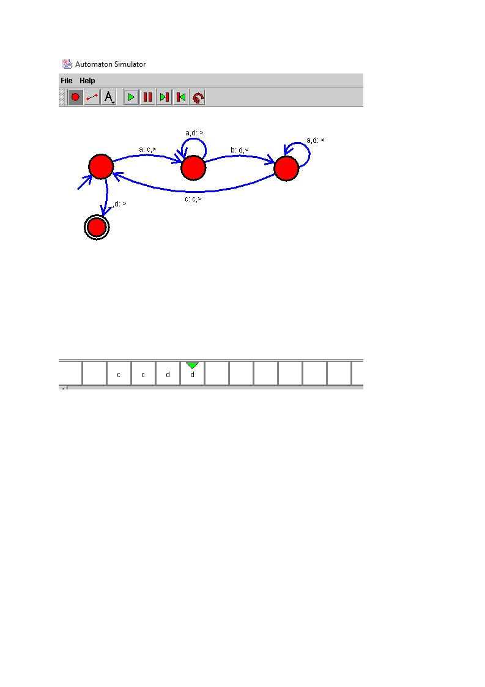**Design and Output:**